**MINI PROJECT**

**(2019-2020)**

**ON**

**EYE PRECAUTIONARY DEVICE**

**Mid Term Report**



**Institute of Engineering & Technology**

**GLA UNIVERSITY, MATHURA**

​**Supervised By:-**​ ​**Team Members:-**

**Mr. Amir Khan Utsah**

**(Technical Trainer) (171500365)**

**Department of Computer Engineering & Applications Pradyumnkumar**

**(171500221)**

**EYE PRECAUTIONARY DEVICE**

**Problem Statement:**

The goal is to make a device that helps to protect our eyes in case we forgot to.

This device simply alarms one to maintain a distance from a **PC,DEKSTOP**if one is

Extremely near to it.

**Reason for selecting the topic:**

Reason behind that is increasing eye problems among kids,adults.old ones .All of them forget to maintain a prefereable distance from a **PC,DESKTOP ETC**.To avoid such type of problems among them ,we make up our mind to build such a device which alarms them for maintaining distance.

**Objective:**

### In this project, we have developed a eye precautionary device using a node mcu 8266.We have used ultrasonic sensors in them for sensing purpose.Whenever any individual gets close to a screened object such as television,desktop,big screens ,there will be a led flash in the device that the individual is too close to the gadget.And that led will continue to glow until the persons maintains an permitted distance with the object.This device is of great use for the childrens,generally they don’t notice their distance from tv and pc. With the help of this project,parents and children themselves can take care of eyes.

**Future Scope:**

In india, eye protective technologies has not come in Indian smart tv.So,only solution is that protecting ourself from the rays.

Sometimes during any show,because of excitement we forget to maintain a distance from tv,with the help of this device,we will get a notification in form of blinking light to remind us of distance.

At a particular distance,ultra sonic sensors will detect and give the input to node mcu 8266 which will let the LED to blink.In this way it is helpful for us.

**Summary**

### 

Normally in human life safety is very most. In this, we used a ultrasonic sensor to detect the distance and warn if distance is not precautionable. All these processes are done by node mcu 8266.

**HARDWARE REQUIRED-**

* **Hardware:**

### **Node mcu 8266**

### **Ultrasonic Sensor**

### **Power Adapter**

* 1. Led

### **Software:**

### **Any Operating System**

### **Arduino IDE**

### **Embedded C**

**Testing Technologies:**

**Functional Testing is** a kind of black box testing that is performed to confirm that the functionality of an application or system is behaving as expected.

**Performance Testing**Perf​ Testing is a type of testing performed to check how application or software performs under workload in terms of responsiveness and stability.

**Applications:**

1. This project can also be used to create a helping stick for older ones.
2. Variation in the model can be introduced according to the need of surrounding and work.

**Progress Details:**

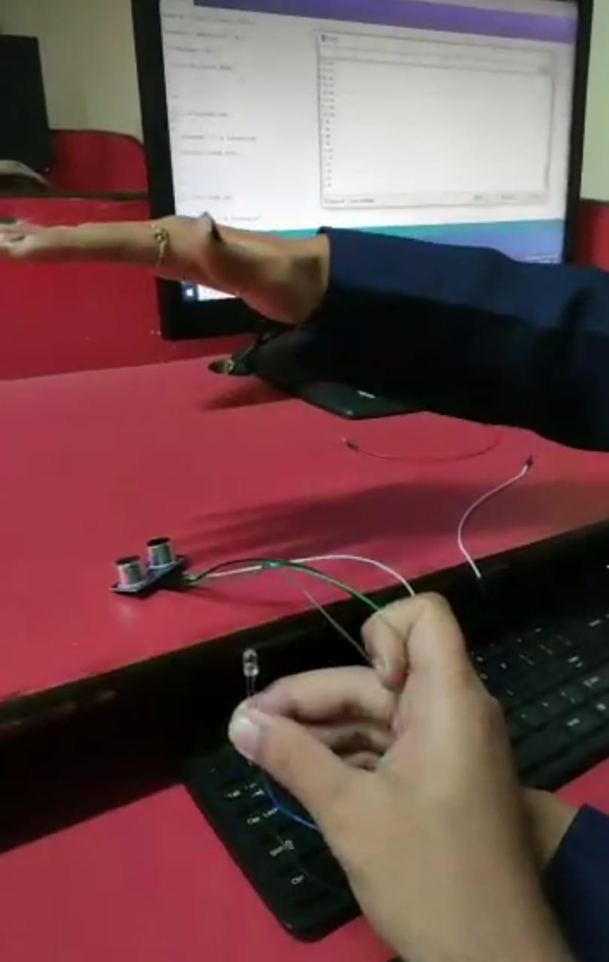 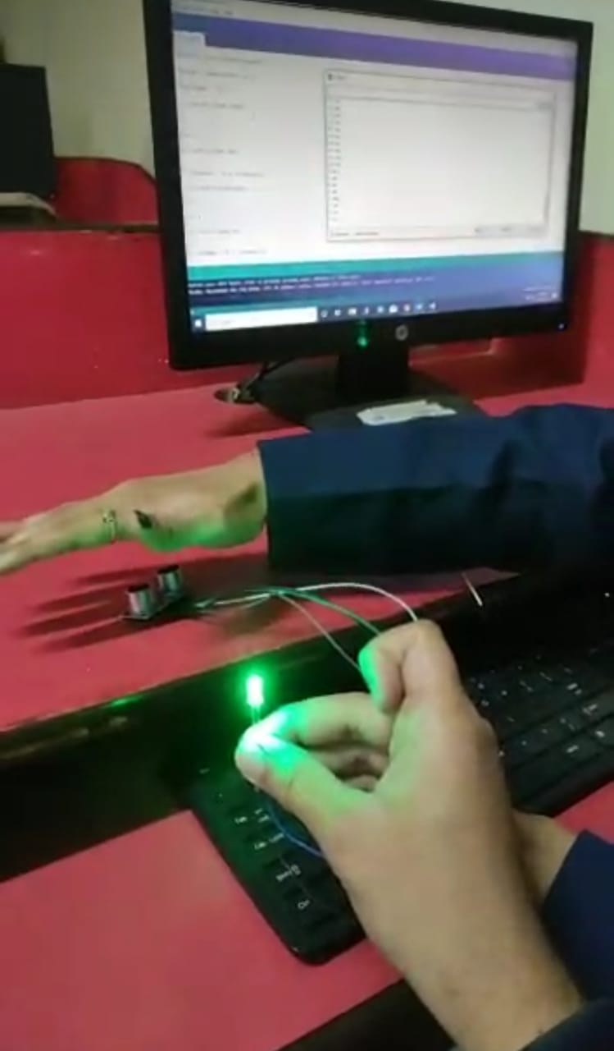

Fig: led will stop glowing when object is away fig:led will glow when object is near from tv. Tv.

**CODE:**

const int trigP = 9;

const int echoP = 10;

long duration;

int distance;

void setup() {

pinMode(D0, OUTPUT);

pinMode(trigP, OUTPUT); // Sets the trigPin as an Output

pinMode(echoP, INPUT); // Sets the echoPin as an Input

Serial.begin(9600); // Open serial channel at 9600 baud rate

}

void loop() {

digitalWrite(trigP, LOW); // Makes trigPin low

delayMicroseconds(2); // 2 micro second delay

digitalWrite(trigP, HIGH); // tigPin high

delayMicroseconds(10); // trigPin high for 10 micro seconds

digitalWrite(trigP, LOW); // trigPin low

duration = pulseIn(echoP, HIGH); //Read echo pin, time in microseconds

distance= duration*0.034/2; //Calculating actual/real distance

if (distance > 70)

{

digitalWrite(D0, HIGH); // turn the LED on (HIGH is the voltage level)

delay(1000);

}

else

{ digitalWrite(D0 , LOW); // turn the LED on (HIGH is the voltage level)

delay(1000);

}

Serial.print("Distance = "); //Output distance on arduino serial monitor

Serial.println(distance);

delay(3000); //Pause for 3 seconds and start measuring distance again

}

**Contribution:**

Hardware part is managed bypradyumnkumar

Software part is done by Utsah.

**References:**

1. [www.coursera.org](http://www.coursera.org/)
2. <https://circuitdigest.com/internet-of-things-iot-projects>
3. <https://www.zapmeta.co.in/>